**Soleeklab Android Task:**

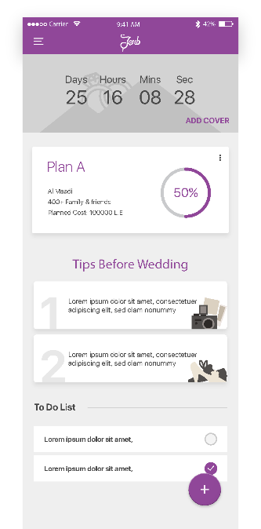Pages will be as follows:

Main Screen:

1. Wedding Date :
   1. It is a count down from the date that user choose to current date.
   2. On click, it will pop up a dialog to enter date.
2. Cover Photo :
   1. By click on add cover, it will pop up a dialog to choose a photo from   
      gallery and replace the current photo.
3. Wedding Date and cover Photo will disappear when the user scroll up   
   and showing only the toolbar and appear again when scroll down
4. Plans List :
   1. At first it will be empty
   2. By clicking the add button (+), add plan screen will open   
      and ask user to add a new plan and it will be add to the list.
   3. Plan items :
      1. Plan name: it will be auto generated alphabetically (Plan A, Plan B...)
      2. Location : by user from add plan screen
      3. No of Guests : by user from add plan screen
      4. Budget : by user from add plan screen
      5. Plan name: it will be auto random generated
5. Tips List :
   1. Load from API
   2. Tips items :
      1. Tip No: it will be auto generated numerically (1, 2, 3...)
      2. Content : from API
      3. Image : API return image name only you should add the URL before it(Check API Documentation)
6. TO-DO List :
   1. Load from API
   2. TO-DO items :
      1. Content : from API
      2. Checkbox: from API

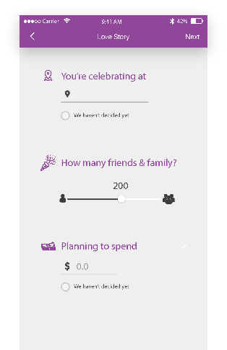Add Plan Screen:

1. Location:
   1. Edit Text with auto complete from government list. (Cairo, Giza…)
   2. If check box marked, Location will be “Any”
2. Guest NO:
   1. It will be from 100 to 1000 guest.
   2. The step value will be 50 (100, 150, 200…)
3. Budget :
   1. Range from 10000 to 100000000
4. Next button(At toolbar):
   1. It will end the screen and add this plan to plans list

You are required to send project code within 1 week to (shirt@soleeklab.com) if you require further information, please contact me on WhatsApp: +201127682299 there is no right or wrong answer, just send your code then we will talk :)

**Best of Luck!!**

**C:\Users\SHIRT\AppData\Local\Microsoft\Windows\INetCache\Content.Word\1.png**